

DEFENCE LOGISTIC SYSTEM

Project Report



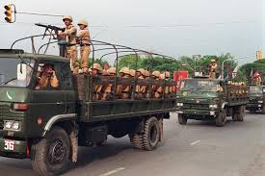

By:

Abdul Samad 19k-0158

Salman Sajid 19k-0196

Siadat Ali 19k-1413

Acknowledgment

1Abdul Samad: 1. The idea of project was discussed with my father who is a retired Army officer and carries a vast experience of Command and staff. 2. geeksforgeeks

2. Siadat: Sibling.

3. Salman Sajid: 1. geeksforgeeks. 2. Mukesh (Classmate)

* Introduction

In army logistic is the most important factor and according there is a famous saying “The army moves on its belly “Coming over to the project being presented is as regard to Calculation where an administrator can easily work out the Calculation as regard to troop, vehicle and fuel ratio in general and is specific on the move. Little Elaborate one can easily calculate the requirement of ration, vehicles, ammunition and fuel at any specific time on need basis.

* **Tools and technologies used**
* Visual Studio / Devc++
* #include<iostream>
* #include <string.h>
* #include<fstream>
* **Link to source**

[A Google Drive or GitHub link to your code repository. The link must be working]

**Future work**

Nutrition factor if added can help out to make an energetic menu as far as food commodities are concerned. On the other hand movement and location of vehicle convoys matter most in battle. Connection with gps could show exact location of road movement, stoppages and any changes of routes can help better to execute the operations.

State of ammunition at any given time during the battle is very critical and can help the administrators to foresee the replenishment plan well in time.

Topics we covered in this project are:

* Single Inheritance
* 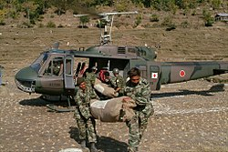Multiple inheritance
* Hybrid inheritance
* Hierarchal inheritance
* Multilevel Inheritance
* Abstract Class
* Data Validation
* Filing
* Operator overloading
* Friends Function
* Function outside the scope
* Function Overriding
* Virtual inheritance
* Method hiding
* Object pointers
* Dynamic allocation

Some proves:

* Abstract class

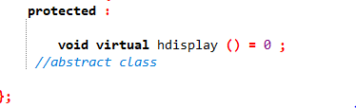

* Multiple Inheritance:

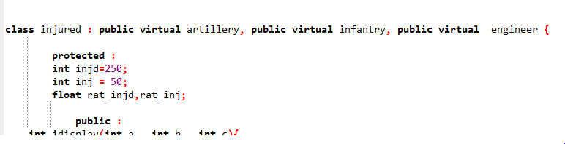

* Hierarchal Inheritance

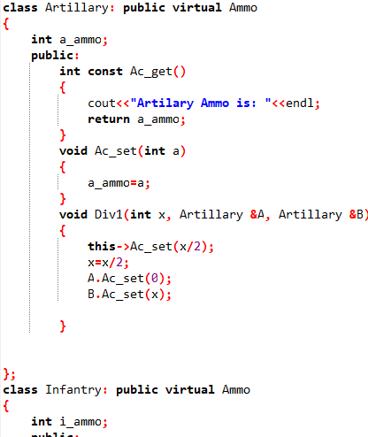

* Hybrid Inheritance

Combination of multiple and hierarchal shows hybrid inheritance as

Ammo to artillery and infantry then both classes to injured.

* Operator overloading:

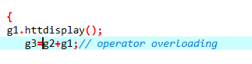

* Filing:

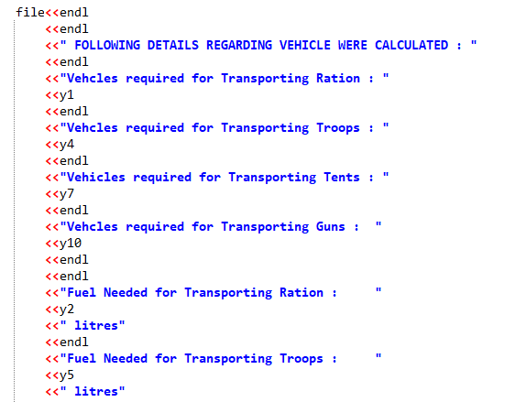

* Object pointer and also dynamic allocation :

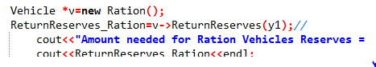

* Data validation:

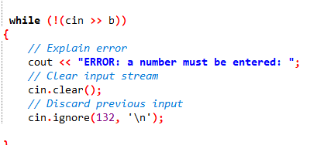

* Function outside the scope:

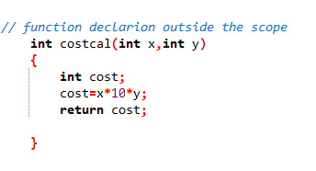

**4. Class diagram**

**[**A class diagram for each class you created. The class diagrams can be shown connected to represent the relationships amongst them, but each of them must have all fields & methods listed. A brief description for each class should also be there in order to explain its purpose]

**Class Diagram:**

These arrow shows relation (HAS A) (IS A)

This arrow shows hierarchy

B

infantry

Defence

A

Protected:

- no_troops;

Public:

+ displays();

Troops

Protected:

-int ration,supp_art,supp_eng;

Public:

+httdisplay(),rtdisplay();

+ operator +();

Rations

Protected:

-Int defence;

+ abstract hdisplay();

protected :

int hol, holi;

float rat_hol, rat_holi;

public :

+ hdisplay()

protected :

-int serv, ser;

-float rat_serv, rat_ser;

public :

+ sdisplay();

protected :

- int injd ,inj;

- float rat_injd,rat_inj;

Public:

+idisplay();

Private:

- Int artilery;

Private:

- Int infantry;

Private:

- Int engineer;

artillery

engineer

holiday

service

injured

B

Infantry

Artillery

- int e_ammo;

public:

+ ec_get(), ec_set() , Div3() ;

gunveh

int a_ammo;

public:

+ Ac_get(), Ac_set() , Div1();

A

public:

- int fuel2,pass_veh=0,passveh2=0;

+ no_needed();

public:

- int fuel2,costR=0,Reserves;

+ReturnReserves(),cost(),fuel(),getdata();

- int distance,xa;

public:

- int n_ammo;

+ A_get();

- int i_ammo;

public:

+ic_get(), ic_set() , Div2();

public:

- float tenveh,tenveh2;

- int fuel2;

+ no_needed()

public:

- int fuel2,costR,Reserves;

+ no_needed()

public:

- intg;float gunveh; int fuel2;

+ no_needed()

TentVeh

PassengerVeh

Engineers

Vehicle

Ration

Ammo